**Slide Sledge Pre-Use Checklist**

1. Apply and test slide lock before removing tool from tool crib. If lock does not hold in the locked or unlocked positions the tool must not be used.

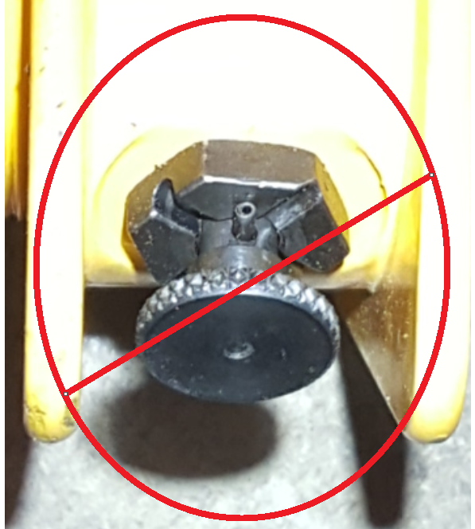 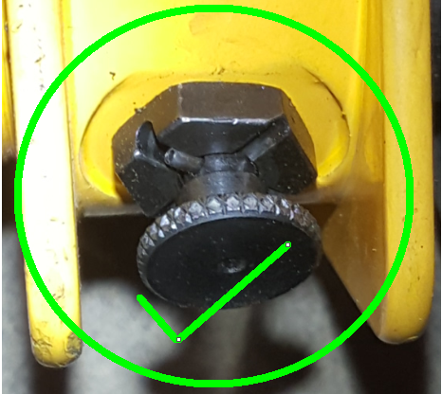

1. Ensure that each section of the tool is properly secured/ threaded together and hasn’t started to loosen off.

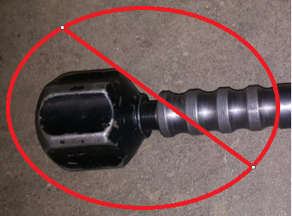 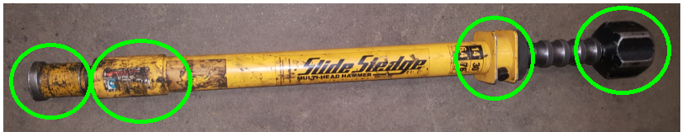

1. Ensure that drive bar cannot slide out of tube and that the tube has not been bent or damaged in any way which may otherwise cause it to not slide in a smooth manner.

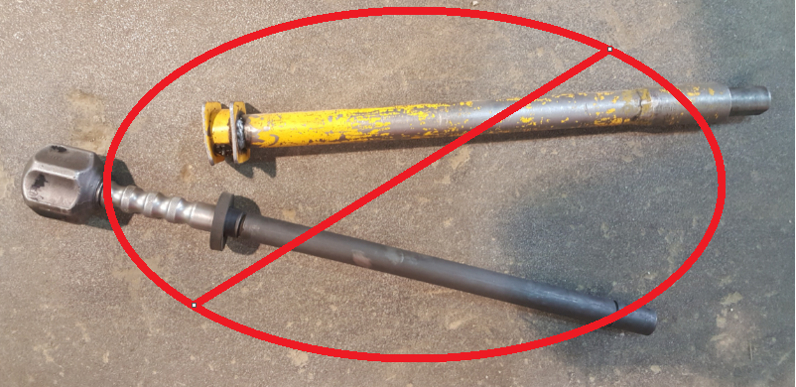

1. Select appropriate sledge and attachment for specific application. Ensure that the tool attachment properly secures in place. NEVER use tool without an attachment as it may damage the tool’s integrity.

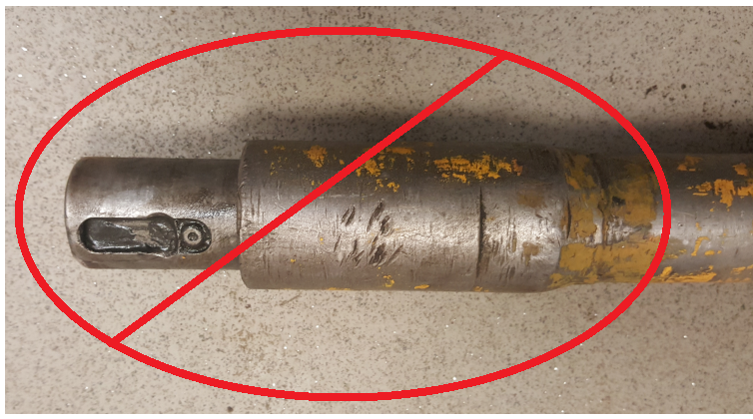 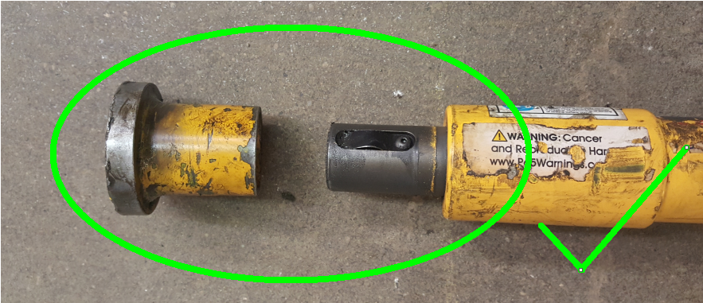

1. Check for presence of rubber hand stop and its condition, threaded cap or weight and overall condition of the tool (e.g. no cracks, chips, missing pieces, bent components or heat damage.

